

## 

# **Parallel Ports (GPIOs)**

Laboratory Report Practice 5

Sebastian Medina Garza A01139531

[Ricardo Cárdenas García](mailto:a01232465@tec.mx)A01232465

[Eduardo Daniel Pérez Caro](mailto:a00823082@tec.mx)A00823082

***Prof. Matías Vázquez***

Monterrey NL México 05/04/2022

**Objectives**

The main objective of this laboratory is to become familiar with the basic instructions for configuring and operating the microcontroller general purpose input/output (GPIO) ports. The student will create the microcontroller firmware that runs the basic operational logic behind a game called Wack-a-mole.

**Introduction**

The Curiosity HPC Development Board is an 8-bit prototyping board. It is designed from the ground-up to take full advantage of Microchip MPLAB X integrated development environment and supports Microchip 28- and 40-pin 8-bit PIC MCUs. Programming/debugging is accomplished through the PICkit On Board (PKOB) circuitry, eliminating the need for external programming/debugging tools.

MPLAB X Integrated Development Environment (IDE) is an expandable, highly configurable software program that incorporates powerful tools to help you discover, configure, develop, debug and qualify embedded designs for most of Microchip microcontrollers and digital signal controllers. MPLAB X IDE works seamlessly with the MPLAB development ecosystem of software and tools, many of which are completely free.

**MPLAB Libraries / Directives / Data Types**

In the first section (figure 1) it’s shown the libraries, it’s where the libraries are defined, in this case are two; device_config.h and math.h. Below the libraries are the directives section, this is in order to reference the pin we want to execute in code. For example PORTDbits.RD3 instead of writing the name of the port it's easy to identify as BUTTON_RD3. The last part of this section is named data types, it’s in order to have two states; input (1) and output (0). And in last are the int, that are the ones the Pat tide fine depths variables we’re going to use later.

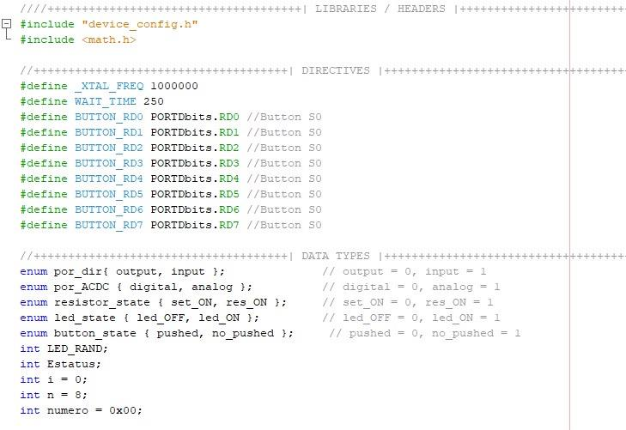

**Main program**

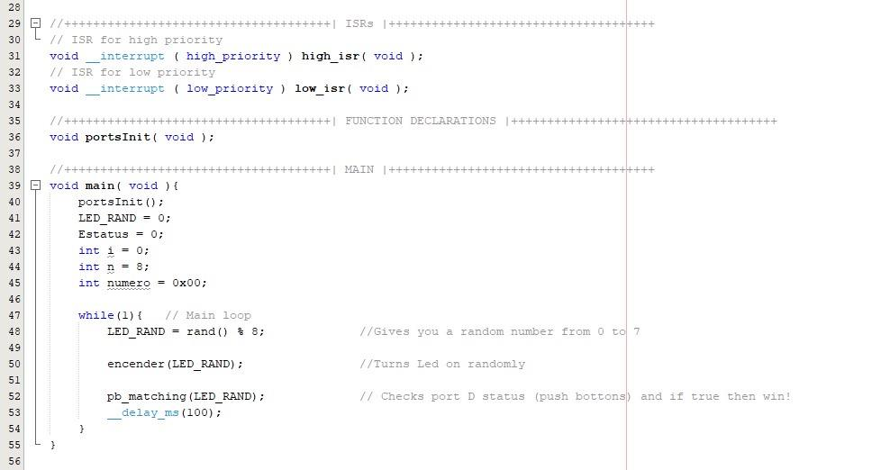

Here is where the main program is executed, portsInit() is the function that will inicializa the variables. LED_RAND, Estatus, and i = 0, n = 8 and número = 0x00.

In the mail loop (while), that starts with LED_RAND is a function that will give random numbers from 0 to 7. This is followed up by encender, that basically depending on the random number that we get in the last function, it’ll turn on the corresponding led.

**Functions**

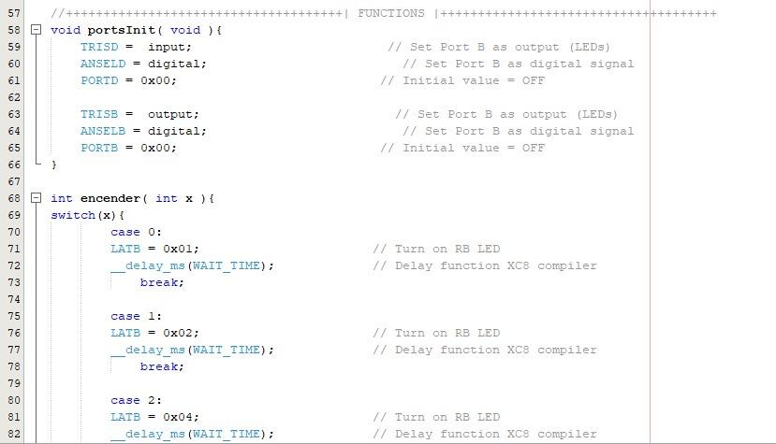

This function with TRISD will set the port B as output, ANSELD is the function that sets the signal to digital and PORTD is the initial value. The function encender, will turn on the LED corresponding to the number randomly generated.

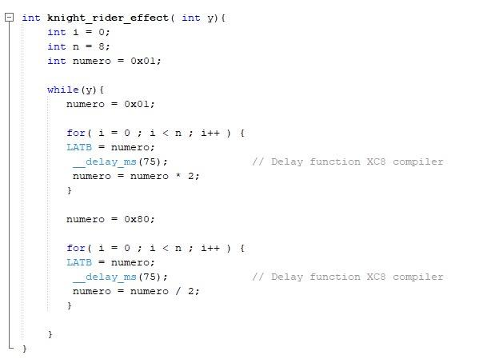

Knight rider will create a led lightning sequence, while y is on, it will execute the first for, that will start in I = 0 until 7, in increments of 1, this is the going secuence. And the return u

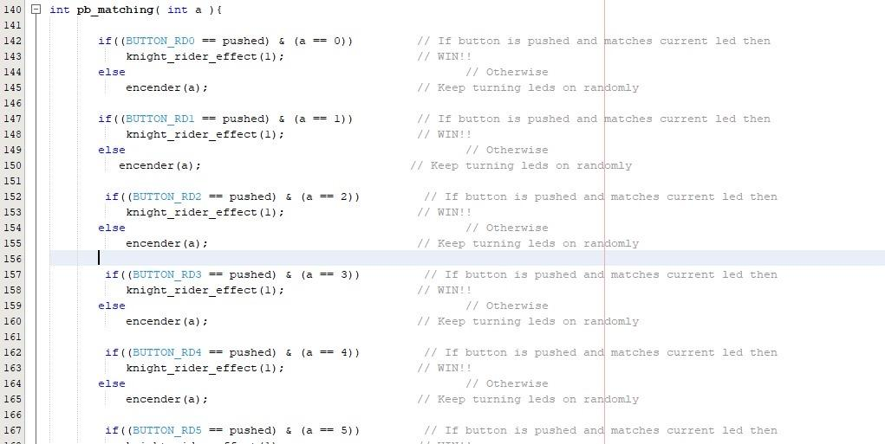

pb_matching will check the push buttons that corresponds to the led that is turn on, for example if push button 2 is pressed and led 1 is on, it will still lighting random leds, in case led 2 is on and push button 2 is on, you will win the game.

**Video:** <https://drive.google.com/file/d/1gkgNzW-j1s-F0nV4UM8H2RUgLwZOyzCL/view?usp=drivesdk>

**Conclusions**

**Sebastian Medina**

This laboratory practice was a very helpful way to get to know better how the PIC18 microcontroller works and how it interacts with the compiler of MPLAB.

**Ricardo Cárdenas**

In this practice we set up the curiosity with the MPLAB software,in which we create a simple game, for as simple as it seems the logic was a little tricky. I'm excited to see what we can achieve with this tools

**Eduardo Perez**

This practice was useful for the introduction and application of the parallel ports of the PIC18, I think this is a very powerful tool for future projects, also the understanding of the concepts was a bit hard at the beginning.

**Reference**

* Matiaz, V. (2022). Introduction to MPLAB X IDE. Retrieved from: [**https://github.com/matias-vazquez/microcontroladores/tree/main/Lab04**](https://github.com/matias-vazquez/microcontroladores/tree/main/Lab04)